JAGAT J L

Module 4 - Test driven development and Logging framework
SL4J Logging exercises
Exercise 1: Logging Error Messages and Warning Levels
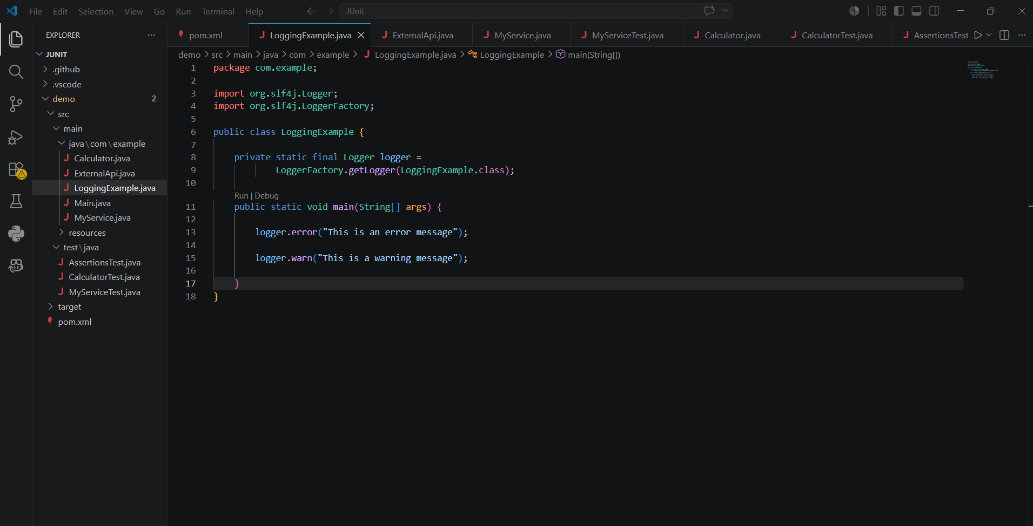
Output
